**Northwind Traders Analysis**

**By**

**Jude C. Uwajeh.**

**INTRODUCTION.**

Northwind Traders is a fictitious gourmet food supplier that manages orders, products, customers, suppliers, and many other aspects of a small business. We have been tasked with identifying key patterns or trends that would help improve the company. This pattern may include, sales trends, most sought-after products, cost changes over the years, and much more.

**DATASET OVERVIEW.**

As shown below, we were provided with 7 Excel files, categories, customers, employees, order_detail, orders, products, and shippers.

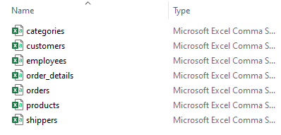

Each Excel file has the information required for the construction of our dashboard such as company name, customer ID, products, shipping company name, and much more.

All Excel files are copied and merged into a single Excel file for easier access.

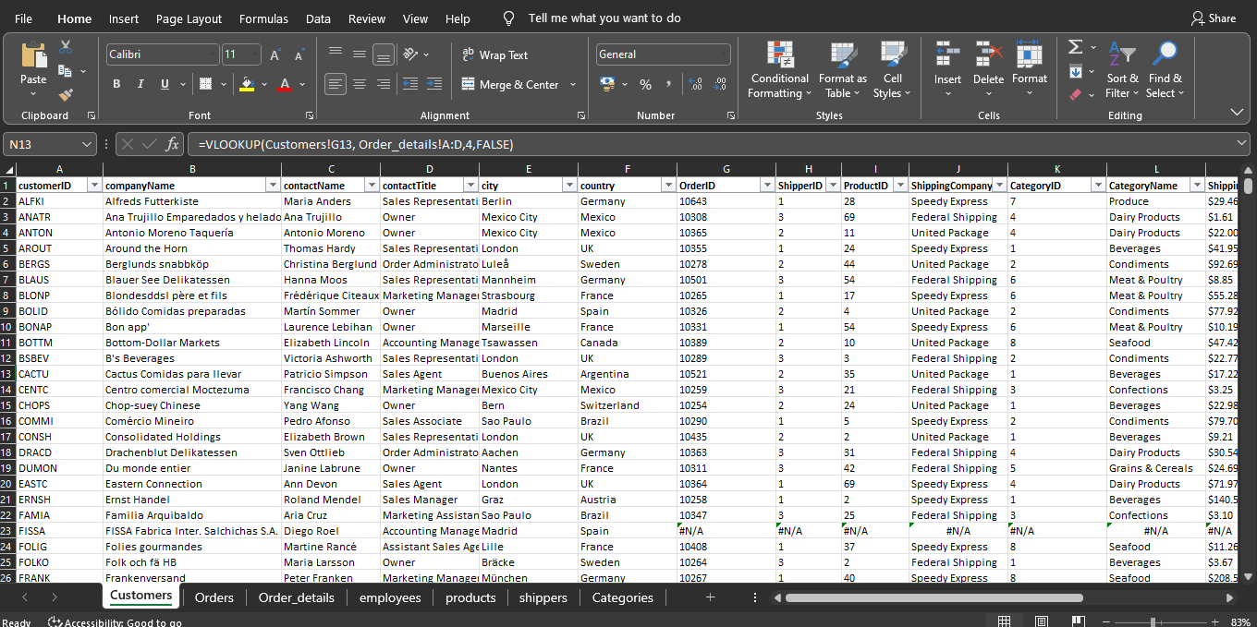

**All Excel files are merged into one sheet.**

We then use Vlookup which means “Vertical Lookup” and is a function in Excel that helps to find a value and pull data from a different part of your spreadsheet based on that value. The formula is given as;

=VLOOKUP(lookup_value, table_array, col_index_num, [range_lookup])

* **lookup_value**: The value to search for in the first column of the **table_array**.
* **table_array**: The range of cells that contains the data to be searched and retrieved.
* **col_index_num**: The column number from which to fetch the data (1 for the first column, 2 for the second, and so on).
* **range_lookup**: TRUE for an approximate match, FALSE for an exact match.

We merged the datasets based on their unique identifiers and removed every null value from our dataset to ensure data accuracy during our analysis.

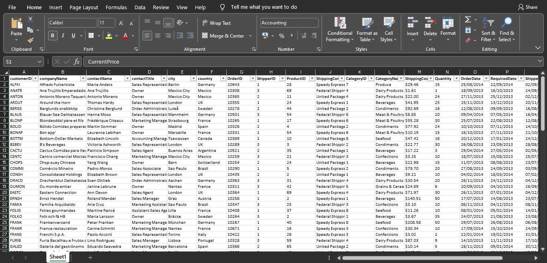

**The dataset was merged and cleaned.**

The dataset is then imported into Microsoft Power BI, which is our visualization tool for this analysis.

**VISUALIZATION.**

The information required by Northwind traders is shown below, with the breakdown of the necessary pieces of information.

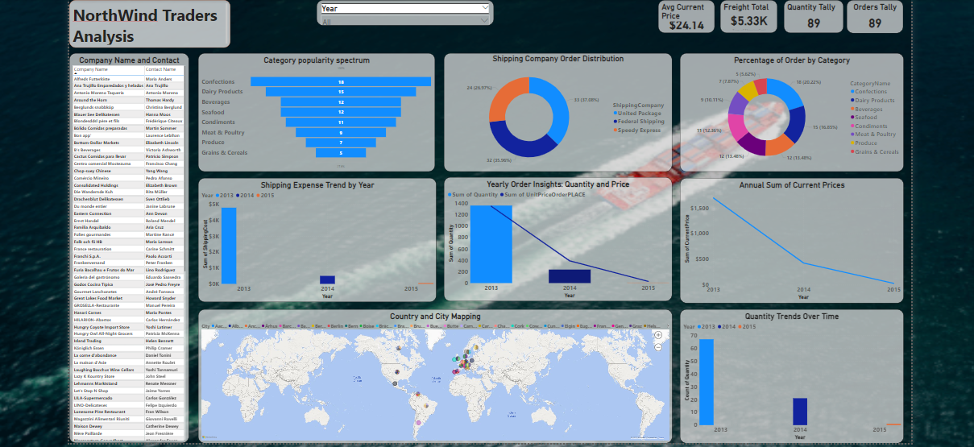

**Northwind Traders Analysis Dashboard.**

The visual above gives the different sales trends performance over the years 2013, 2014, and 2015 for products which include, Beverages, Confections, Dairy products, Seafood, Condiments, Meat and poultry, Produce, Grain and cereals

With shipping companies being; United Package, Federal Shipping, and Speedy Express.

**In 2013.**

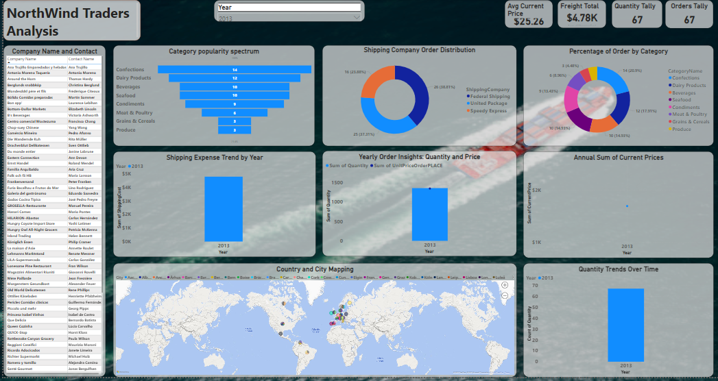

**Analysis for the year, 2013.**

From the visual above, we can observe the following;

* The average current price of products is $25.26
* The Freight total or total shipping cost is $4,778
* Total quantity and orders sold/made for the year, are 67.
* The sum of the Unit price of orders at $1350 and the sum of the current price at $1692.24.
* The most popular products on the popularity spectrum are Confections 14, Dairy products 12, and the least popular products are Grain and cereals 3, and produce 3.
* The most used shipping company for the year is Federal Shipping at 38.81%, United Package not too far behind at 37.81%, and Speedy Express at 23.88%.

**In 2014.**

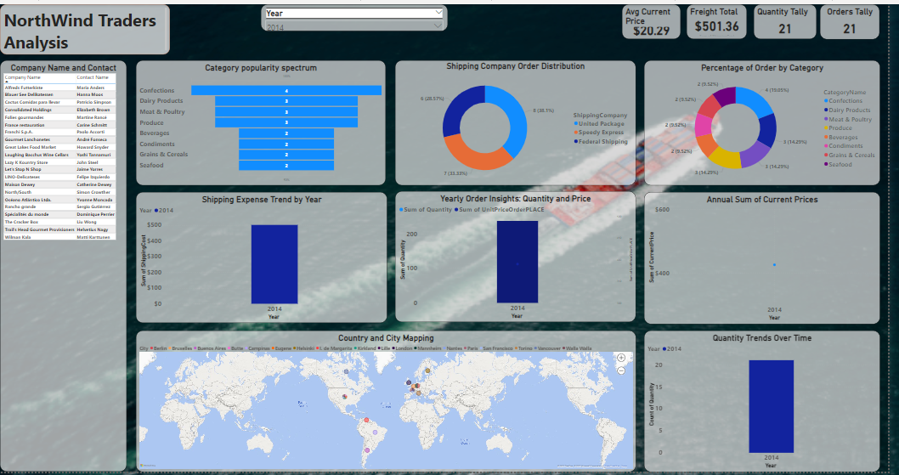

**Analysis for the year, 2014.**

From the visual above, we can observe the following;

* The average current price of products is $20.29
* The Freight total or total shipping cost is $501.36 with a massive reduction of 89.51% from the previous year.
* Total quantity, and orders sold/made for the year, are 21.
* The sum of the Unit price of orders at $237 and the sum of the current price at $426.16, The most popular products on the popularity spectrum are Confections 4, Dairy products 3, and the least popular products are Grain and cereals 2, seafood 2, Beverages 2, and condiments 2.
* The most used shipping company for the year is Federal Shipping at 38.1%, United Package not too far behind at 33.33%, and Speedy Express at 28.57%, There was a massive decrease in shipping products this is due to the decrease in orders for the year.

**In 2015.**

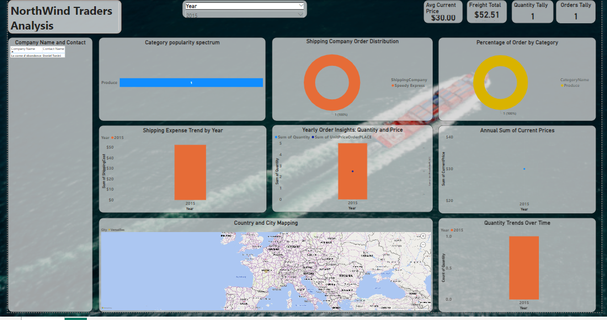

**Analysis for the year, 2015.**

From the visual above, we can observe the following;

* The average current price of products is $30.00, and the Freight total or total shipping cost is $52.51 with a massive reduction from 2014 – 2015 at 89.51% and 2013 – 2015 at 98.91%.
* Total quantity, and orders sold/made for the year, are 1, the order being made by Daniel Tonini of La corne d'abondance.
* The sum of the Unit price of orders at $30 and the sum of the current price at $30.
* The only product purchased was produce, and Speedy Express was the shipping company used for the delivery.

**INSIGHTS AND RECOMMENDATIONS.**

* **Sales Trends Analysis**: The analysis of sales trends over the years (2013, 2014, and 2015) reveals several key insights. The average current price of products fluctuated, with the highest average in 2015. However, it's notable that the sales quantity and the total shipping cost saw significant variations, indicating the need for further investigation into underlying factors.
* **Shipping Company Performance:** The dominance of Federal Shipping as the most used shipping company in 2013 and 2014 underscores its popularity. However, there was a decrease in shipping activity in 2014, affecting both the total shipping cost and the choice of shipping company. Understanding the reasons behind this decrease could lead to more effective shipping strategies.
* **Product Popularity:** The popularity spectrum of products gives insight into customer preferences. The rise and fall in popularity of different products across the years highlight changing consumer demands. This information can guide inventory management, promotion strategies, and product development efforts.
* **Customer behavior and Retention:** The order quantity analysis reveals a single order in 2015, indicating a potential decline in customer activity. Exploring reasons for this drop, such as changes in customer preferences, market conditions, or competitive factors, can help in devising strategies to attract and retain customers.

**CONCLUSION.**

the analysis of Northwind Traders' dataset has unveiled significant insights into the company's performance over the years 2013, 2014, and 2015. The examination of sales trends, shipping company preferences, product popularity, cost dynamics, and customer behavior has provided a comprehensive understanding of the business landscape.

These insights emphasize the dynamic nature of the market, highlighting the importance of adaptability and informed decision-making. Northwind Traders can capitalize on these findings to make strategic adjustments that will enhance their competitiveness and sustain growth.

The recommendations stemming from the analysis encourage Northwind Traders to diversify their product strategy, optimize shipping processes, engage customers proactively, consider market expansion, and maintain a continuous cycle of data analysis. By heeding these suggestions, the company can foster resilience, customer satisfaction, and long-term success.

Incorporating data-driven practices and acting upon these insights will empower Northwind Traders to navigate challenges, seize opportunities, and continue to flourish in a rapidly evolving business environment.